Sept 4 2025 BDBP106: Linux and Python Programming Lab 14 Ankita Bose (PhD)

(1) Arithmetic operations and operator precedence Predict and check your results
for the following arithmetic operations
(i) 2.7/2
(ii) 2.7//2
(iii) 10+5j/2
(iv) complex(2.2, 5.3).conjugate().imag Note that the operation is from left to right.
(v) round(2.5)
(vi) round(-2.5)
(vii) 2//4-1
(viii) 3*2**2
(ix) 3**2*2
(x) 7//4
(xi) 7%4
(xii) -7%4
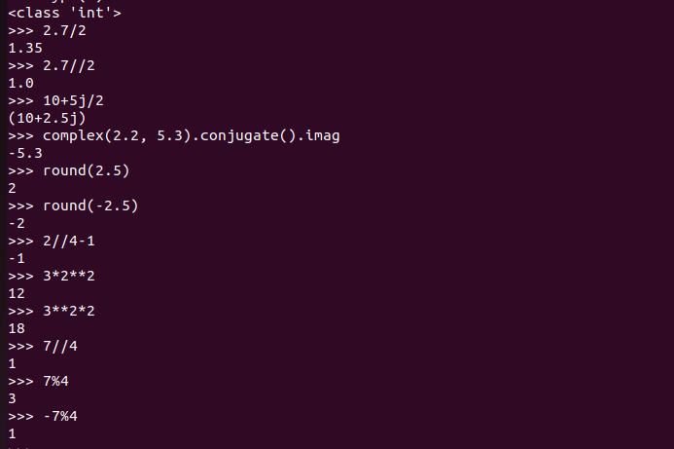
(2) Logical operations Predict and check your results for the following boolean operations.
Assign the values 1,2,4 respectively to a,b and c and do the following
(i) a and b
(ii) not a<b or c>b
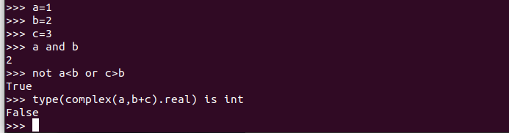
(iii) type(complex(a,b+c).real) is int

